# Task Description#2

Q) Use Copilot to generate a is_prime() Python function?

#Prompt-1: is_prime() python function

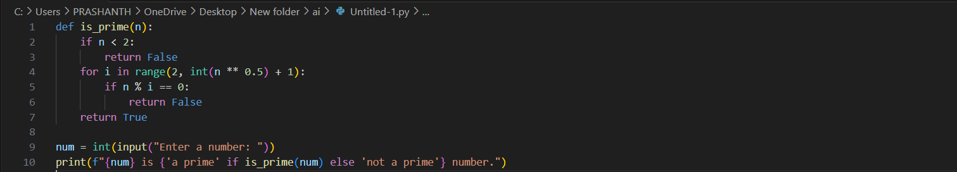

#Prompt-2: Check the given number is prime or not

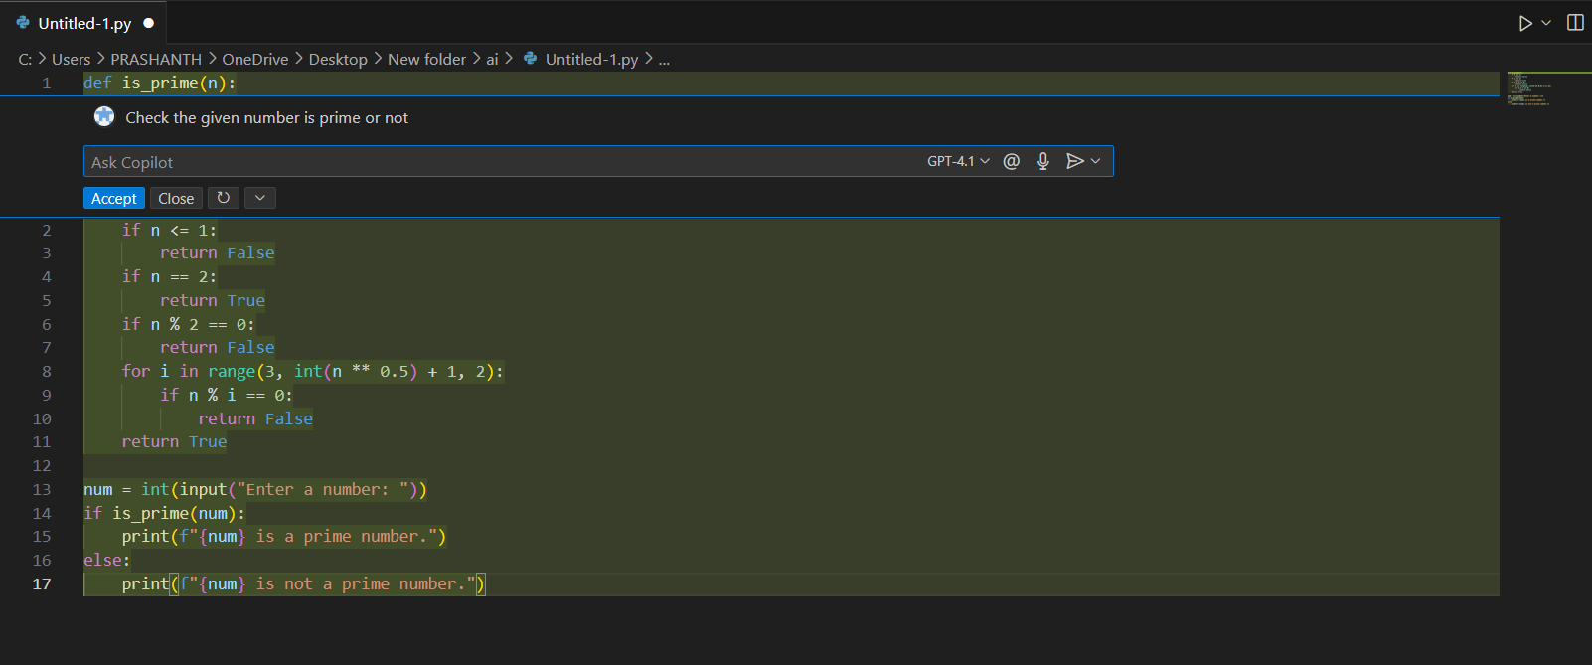

OUTPUT:





# Task Description#3

Q) Write a comment like # function to reverse a string and use copilot to generate the function

# PROMPT -1: Reverse the given string

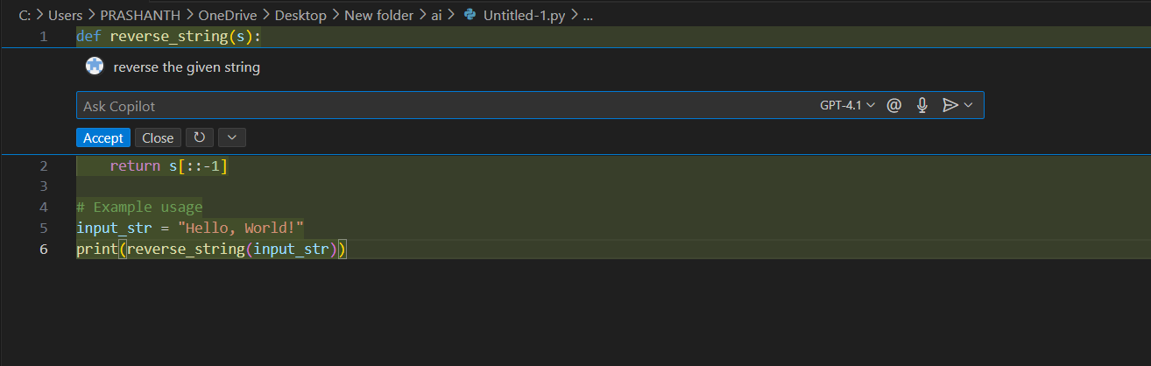

#PROMPT -2: Use function to reverse a string

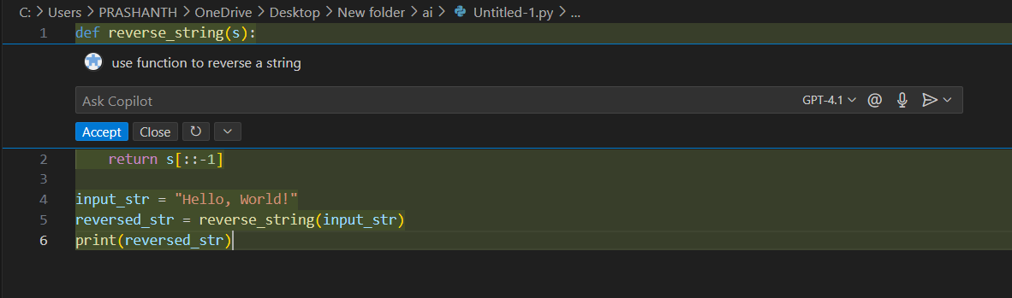

OUTPUT:



# 

# Task Description #4

Q) Genarate both recursive and iterative versions of a factorial function using comments.

# PROMPT -1: recursive and iterative versions of a factorial function

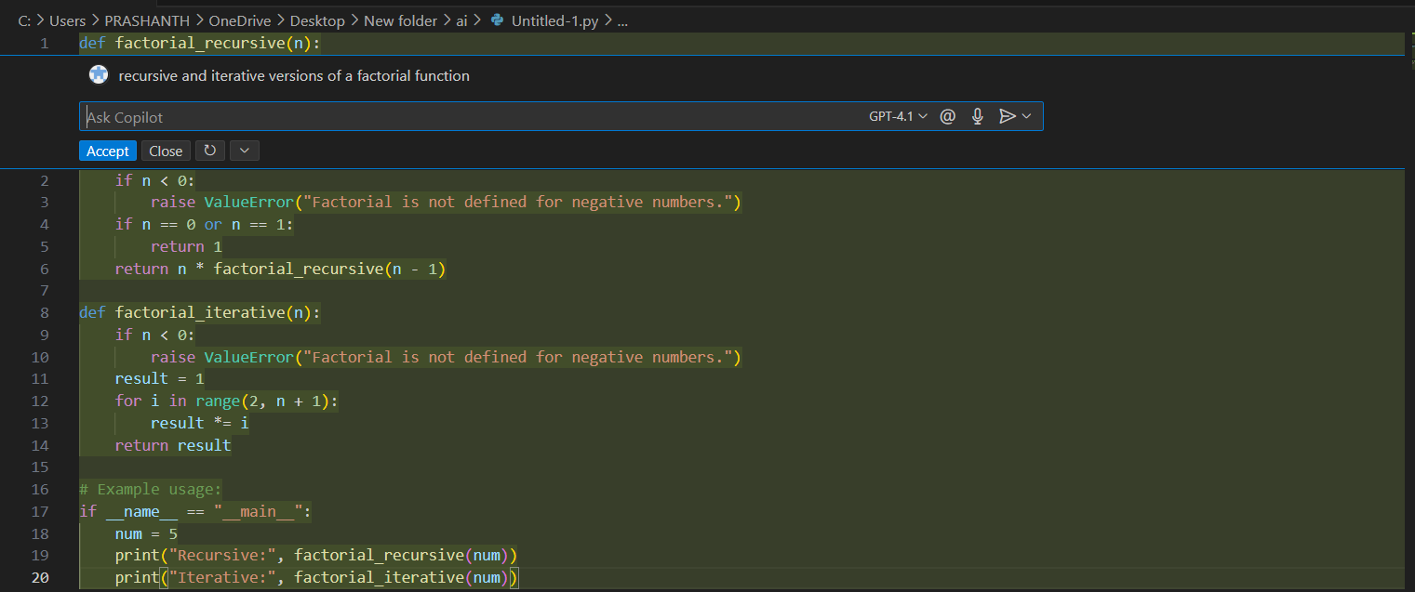

# PROMPT -2: factorial function of recursive and iterative

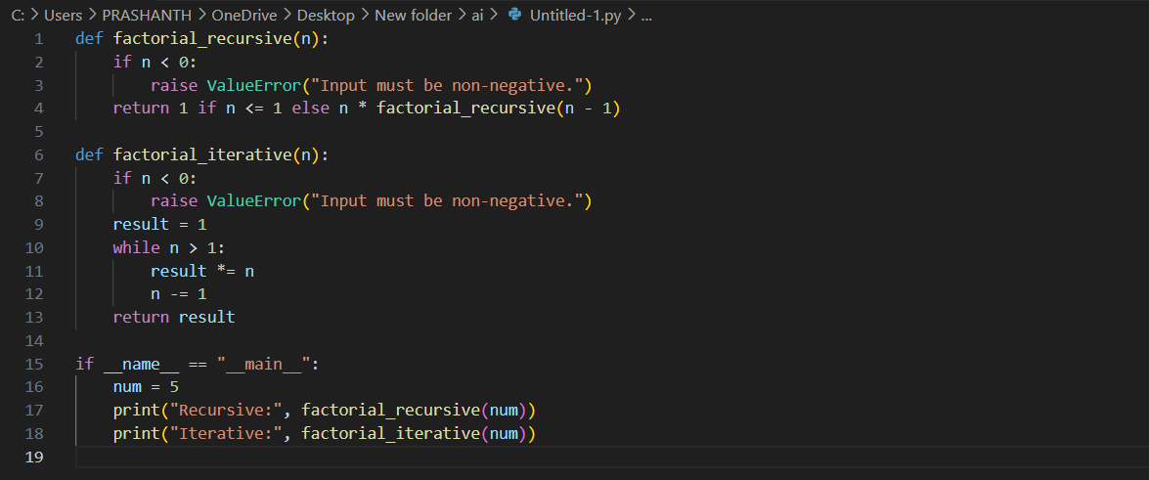

OUTPUT:



# 

# Task Description #5

Q) Use copilot to find the largest number in a list assess code quality and efficiency.

#Prompt -1: largest number in a list and assess code quality and efficiency

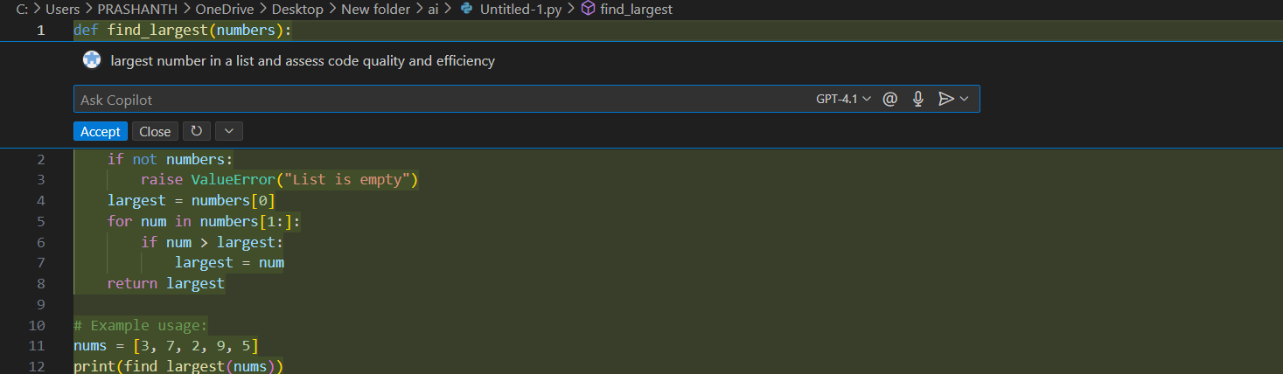

#Prompt -2: Write a largest number in a list and assess code quality and efficiency

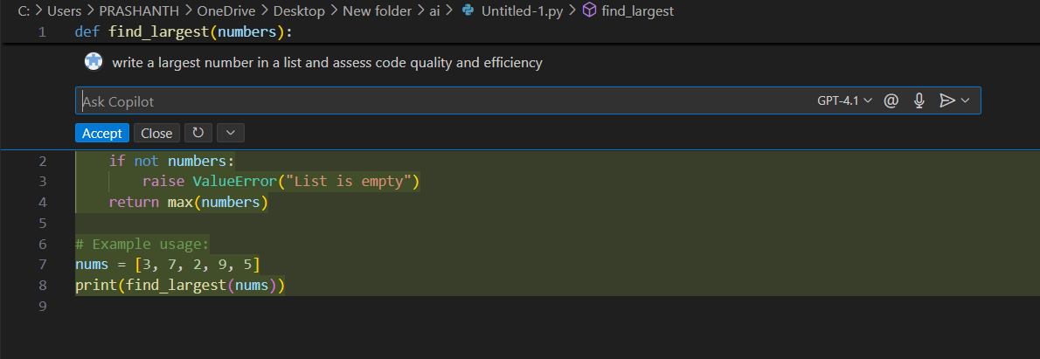

OUTPUT:

